American Vacuum Society Hudson Mohawk Chapter
Spring 2018 meeting

The 2018 Spring meeting of the Hudson Mohawk Chapter of the AVS took place on Monday, April 30, 2018 4 – 8 PM at GE Global Research Center in Niskayuna, New York.
The meeting was attended by more than 40 professors, researchers, industry experts, graduate and undergraduate students. The meeting comprised six invited talks with the theme “Additive Manufacturing” followed by a poster session and an informal networking event.

Dr. Vincent Smentkowski opened with a welcome note to all the speakers and attendees followed by an introduction to and the advantages of AVS chapter membership. The focused session on additive manufacturing (AM) began with a talk on direct metal laser milling given by Dr. William Carter from GE Global Research (GE-GRC). Dr. Laura Dial from GE-GRC discussed materials needed for beam-based powder bed AM. Justin Gambone of GE-GRC spoke about in-process analytics and controls for powder bed fusion in AM. Dr. Andrey Meshkov, GE-GRC, gave a spirited presentation on the role of high fidelity melt pool modeling of powder bed fusion AM. Dr. Arun Natarajan of GE-GRC spoke about the role of binder jet technology for AM. Dr. Steven Attanasio from Naval Nuclear Laboratory spoke about the role of additive manufacturing in elucidating the microstructure of stainless steel.

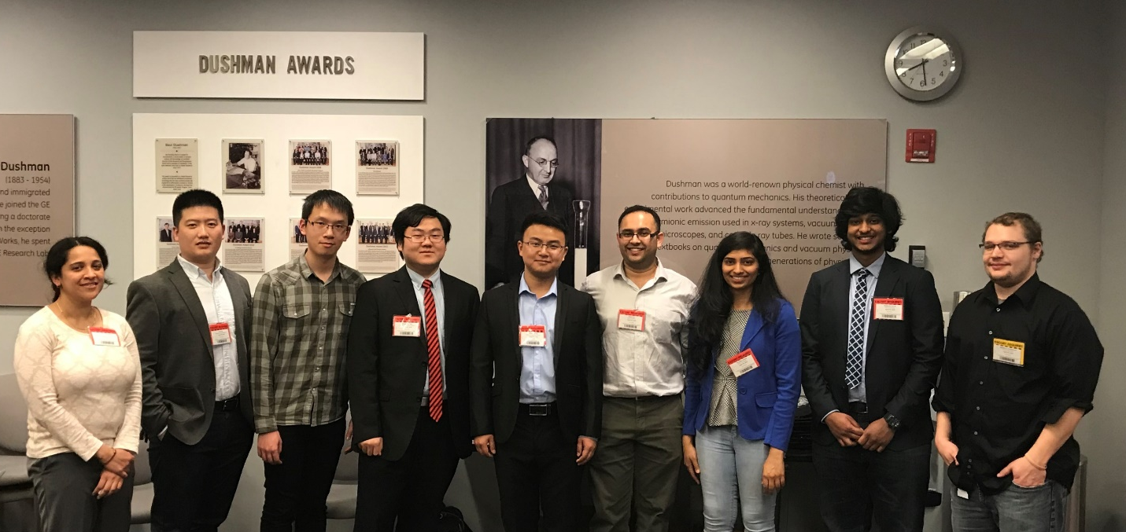
Student poster presenters with chapter chair during Spring 2018 meeting of the Hudson Mohawk chapter of the American Vacuum Society. From left to right, Vineetha Mukundan, Xin Sun, Xi Wang, Zhizhong Chen, Baiwei Wang (graduate best poster winner), Sonal Dey (chapter chair), Mounka Kotha (graduate second best poster winner), Siddarth Laveti (undergraduate best poster winner), and Matthew Strohmayer.

Graduate students, undergraduate students, and postdoctoral researchers presented nine posters in the session after the break. The poster by Siddarth Laveti from the Colleges of Nanoscale Science and Engineering SUNY Polytechnic Institute (CNSE), “Optimization of the Growth of Graphene on Cu Foil Substrates by Chemical Vapor Deposition”, was awarded the best undergraduate poster. Baiwei Wang (Rensselaer Polytechnic Institute) presented “Growth and Properties of Epitaxial Ti_{1−x}Mg_{x}N (001) Layers” and captured best graduate poster. Mounika Kotha’s (CNSE) poster “The Effect of Oxidation on the Raman and Photoluminescence Properties of Unpassivated and Novel-passivated Layered GaTe” took second graduate poster by the judges.

The chair of the chapter, Dr. Sonal Dey, presided over the meeting of the executive committee. Members of the executive committee, Drs. Michael Burrell, J. Scott Price, John Chera, Vincent Smentkowski, David Surman, and Carl Ventrice attended the meeting. The plans for next chapter meeting was discussed and the Colleges of Nanoscale Science and Engineering SUNY Polytechnic Institute at Albany, New York was decided to be the venue for the Fall Meeting of the chapter.

